**Road Accident Project Query**

SELECT Accident_Date

FROM road_accident;

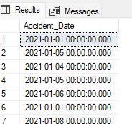

**-- create Acc_date column for accident date**

ALTER TABLE road_accident

ADD Acc_date DATE;

**-- Accident_Date column has date and time. so take only date from Accident_Date and insert in Acc_date column**

UPDATE road_accident

SET Acc_date = CAST(Accident_Date AS DATE);

|  |
| --- |
| SELECT Acc_date  FROM road_accident; |

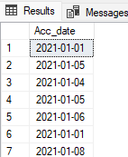

-- create column for month, day(number), Time and year separately

ALTER TABLE road_accident

ADD YEAR int;

ALTER TABLE road_accident

ADD Month VARCHAR(50);

ALTER TABLE road_accident

ADD Acc_Day int; -- in number

ALTER TABLE road_accident

ADD day_name VARCHAR(50); -- in char

-- Time

ALTER TABLE road_accident

ADD acc_time TIME;

-- drop

ALTER TABLE road_accident

DROP COLUMN Day;

--

UPDATE road_accident

SET YEAR = YEAR(Accident_Date);

UPDATE road_accident

SET Acc_Day = DAY(Accident_Date);

-- Time

UPDATE road_accident

SET acc_time = CAST(Time AS TIME);

-- In year, 1 means 'january'

UPDATE road_accident

SET MONTH = CASE

WHEN MONTH(Accident_Date) = 1 THEN 'January'

WHEN MONTH(Accident_Date) = 2 THEN 'February'

WHEN MONTH(Accident_Date) = 3 THEN 'March'

WHEN MONTH(Accident_Date) = 4 THEN 'April'

WHEN MONTH(Accident_Date) = 5 THEN 'May'

WHEN MONTH(Accident_Date) = 6 THEN 'June'

WHEN MONTH(Accident_Date) = 7 THEN 'July'

WHEN MONTH(Accident_Date) = 8 THEN 'August'

WHEN MONTH(Accident_Date) = 9 THEN 'September'

WHEN MONTH(Accident_Date) = 10 THEN 'October'

WHEN MONTH(Accident_Date) = 11 THEN 'November'

WHEN MONTH(Accident_Date) = 12 THEN 'December'

END;

-- To update day_name like 'Sunday'

UPDATE road_accident

SET day_name = DATENAME(WEEKDAY, Accident_Date);

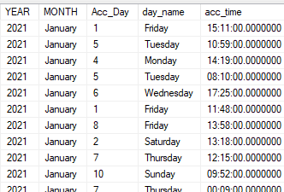

-- To Find Total Casualties

SELECT SUM(Number_of_casualties) as TotalCasualties

FROM road_accident;

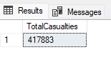

-- Group data by Accident_severity (serious, slight, Fatal)

SELECT Accident_Severity

FROM road_accident

WHERE Accident_Severity = 'Fetal';

UPDATE road_accident

set Accident_Severity = 'Fatal'

WHERE Accident_Severity = 'Fetal';

-- Total casualties by Accident_Severity

SELECT Accident_Severity, SUM(Number_of_Casualties) As TotalCasualties

FROM road_accident

GROUP BY Accident_Severity

ORDER BY TotalCasualties;

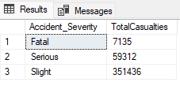

-- casualties by vehicle

ALTER TABLE road_accident

ADD Grouped_Vehicle VARCHAR(100);

UPDATE road_accident

SET Grouped_Vehicle = Vehicle_Type;

UPDATE road_accident

SET Grouped_Vehicle = 'Car'

WHERE Grouped_Vehicle = 'Taxi/Private hire car';

UPDATE road_accident

SET Grouped_Vehicle = 'Bus'

WHERE Grouped_Vehicle = 'Bus or coach (17 or more pass seats)'

OR Grouped_Vehicle = 'Minibus (8 - 16 passenger seats)';

UPDATE road_accident

SET Grouped_Vehicle = 'Van'

WHERE Grouped_Vehicle = 'Goods over 3.5t. and under 7.5t'

OR Grouped_Vehicle = 'Goods 7.5 tonnes mgw and over'

OR Grouped_Vehicle = 'Van / Goods 3.5 tonnes mgw or under';

UPDATE road_accident

SET Grouped_Vehicle = 'Bike'

WHERE Grouped_Vehicle = 'Motorcycle 50cc and under'

OR Grouped_Vehicle = 'Motorcycle over 500cc'

OR Grouped_Vehicle = 'Motorcycle over 125cc and up to 500cc'

OR Grouped_Vehicle = 'Motorcycle 125cc and under';

UPDATE road_accident

SET Grouped_Vehicle = 'Others'

WHERE Grouped_Vehicle = 'Other vehicle'

OR Grouped_Vehicle = 'Pedal cycle'

OR Grouped_Vehicle = 'Ridden horse';

SELECT Vehicle_Type, SUM(Number_of_Casualties)

FROM road_accident

GROUP BY Vehicle_Type;

SELECT Grouped_Vehicle, SUM(Number_of_Casualties) As TotalCasualties

FROM road_accident

GROUP BY Grouped_Vehicle

ORDER BY TotalCasualties;

**Original Data**

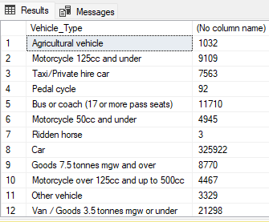

Output:

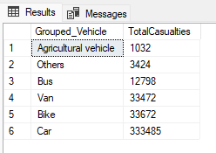

-- percentage of fatal, serious, slight severity

SELECT SUM(Number_of_Casualties) AS TotalCasualties

FROM road_accident;

SELECT Accident_Severity, SUM(Number_of_Casualties) As TotalCasualties

FROM road_accident

GROUP BY Accident_Severity

ORDER BY TotalCasualties;

SELECT Accident_Severity,SUM(Number_of_Casualties) TotalCasualties,

CAST(SUM(Number_of_Casualties) * 100 / (SELECT SUM(Number_of_Casualties) FROM road_accident)AS DECIMAL(10,2)) AS Percentage

FROM road_accident

GROUP BY Accident_Severity

ORDER BY Percentage;

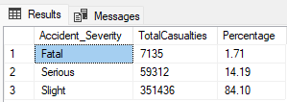

-- percentage for vehicle type

SELECT Grouped_Vehicle, SUM(Number_of_Casualties) As TotalCasualties

FROM road_accident

GROUP BY Grouped_Vehicle

ORDER BY TotalCasualties;

SELECT Grouped_Vehicle, SUM(Number_of_Casualties) As TotalCasualties,

CAST(SUM(Number_of_Casualties) * 100 / (SELECT SUM(Number_of_Casualties) FROM road_accident)AS DECIMAL(10,1)) AS Percentage

FROM road_accident

GROUP BY Grouped_Vehicle

ORDER BY TotalCasualties;

**Original Data:**

==============

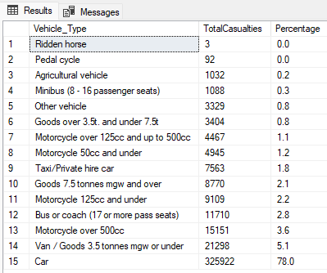

Output:

=========

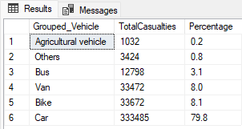

-- casualties by road type

SELECT * FROM road_accident;

SELECT Road_Type, SUM(Number_of_Casualties) As TotalCasualties

FROM road_accident

GROUP BY Road_Type;

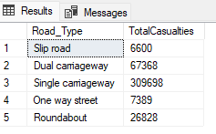

-- casualties by road surface

ALTER TABLE road_accident

ADD Grouped_road_surface VARCHAR(100);

UPDATE road_accident

SET Grouped_road_surface = Road_Surface_Conditions;

UPDATE road_accident

SET Grouped_road_surface = 'Wet'

WHERE Grouped_road_surface = 'Wet or damp'

OR Grouped_road_surface = 'Flood over 3cm. deep';

UPDATE road_accident

SET Grouped_road_surface = 'Snow/Ice'

WHERE Grouped_road_surface = 'Snow'

OR Grouped_road_surface = 'Frost or ice';

SELECT Grouped_road_surface, SUM(Number_of_Casualties) As TotalCasualties

FROM road_accident

GROUP BY Grouped_road_surface;

Original Data:

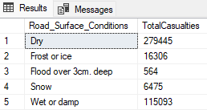

Output:

=======

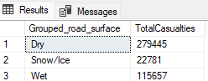

-- casualties by day / night

ALTER TABLE road_accident

ADD Grouped_light_conditions VARCHAR(100);

UPDATE road_accident

SET Grouped_light_conditions = Light_Conditions;

UPDATE road_accident

SET Grouped_light_conditions = 'Night'

WHERE Grouped_light_conditions = 'Darkness - lights lit'

OR Grouped_light_conditions = 'Darkness - lights unlit'

OR Grouped_light_conditions = 'Darkness - lighting unknown'

OR Grouped_light_conditions = 'Darkness - no lighting';

SELECT Grouped_light_conditions, SUM(Number_of_Casualties) As TotalCasualties

FROM road_accident

GROUP BY Grouped_light_conditions;

**Original Data:**

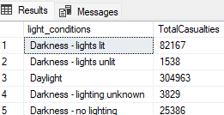

**Output:**

=======

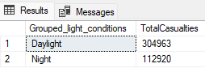

-- casualties by area (rural / urban)

SELECT Urban_or_Rural_Area, SUM(Number_of_Casualties) As TotalCasualties

FROM road_accident

GROUP BY Urban_or_Rural_Area;

